DATA ANALYTICS

ASSIGNMENT 5

FORECASTING MODELS

TEAM MEMBERS

NAME SRN  
VIMARSHA R PES1201701590

VINUTHA M N PES1201701373

KEERTHI PRIYA P PES1201701643

**FORECASTING TECHNIQUES:**

To forecast a time series data,we need to consider many components associated such as cyclical component, seasonal component and trend component. Hence forecasting techniques are used.

There are many forecasting techniques developed based on different logistics.Some of those implemented here are

1) AutoRegressive Models

2)Single Exponential Smoothing

3) Double Exponential Smoothing

4)Triple Exponential Smoothing.

Forecasting Accuracy techniques namely Mean Absolute Percentage Error(MAPE) and Root Mean Square Error(RMSE) has been calculated as well.

**AUTO-REGRESSIVE MODEL:**

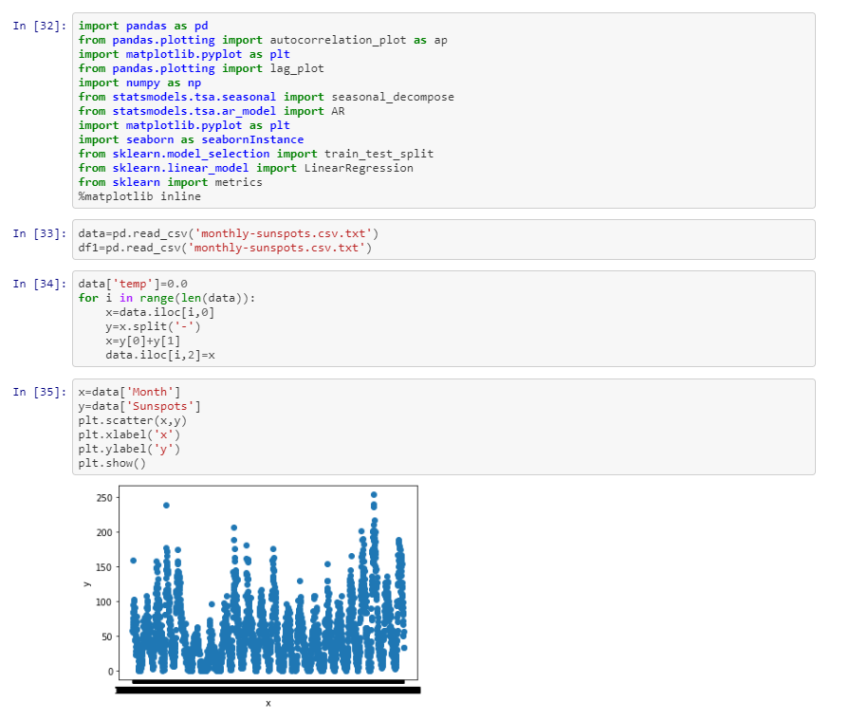

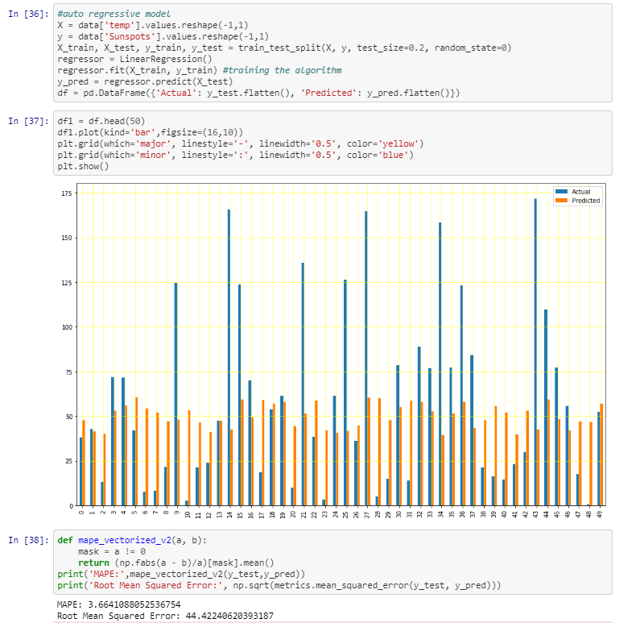

**SINGLE EXPONENTIAL SMOOTHING:**

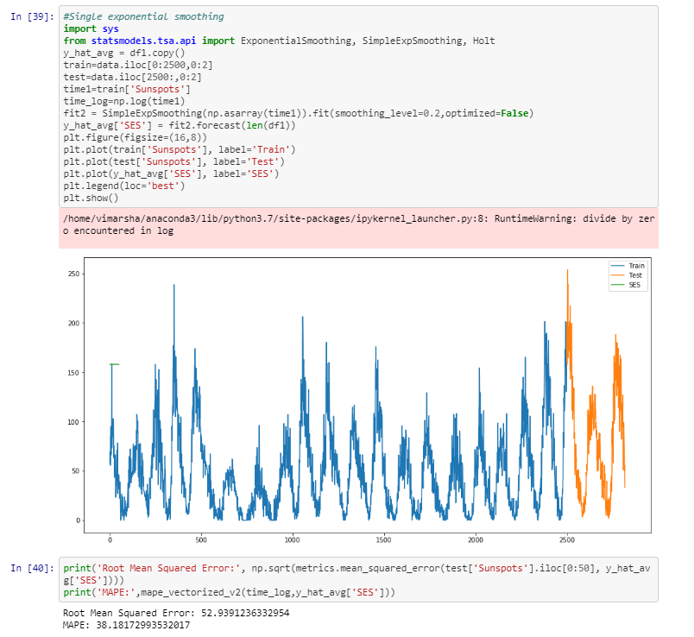

**DOUBLE EXPONENTIAL SMOOTHING:**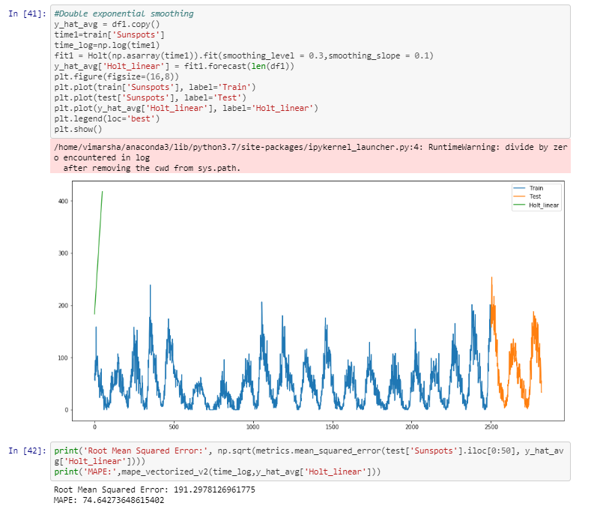

**TRIPLE EXPONENTIAL SMOOTHING:**

